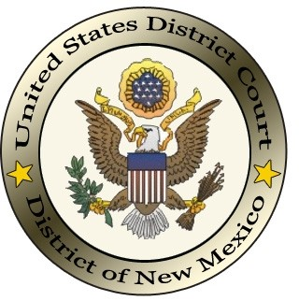
UNITED STATES DISTRICT COURT
DISTRICT OF NEW MEXICO

Attorney Certificate of Good Standing
Request Form

Please complete the form and along with payment **(refer to the current fee schedule) submit to the Clerk’s Office in person at the courthouse, or by mailing it to:

United States Courthouse
333 Lomas Blvd, Ste 270
Albuquerque, NM 87102

Attorney’s Name:
Bar ID:

Contact Information:
Phone Number:
Email:

**Payments cannot be made online. In person, any form of payment is accepted, exact change only. Payments that are mailed must be by money order or check.

Certificates of Good Standing will be returned to the address of record for the attorney via USPS. However, if a preaddressed and stamped envelope is included, the Clerk’s Office will utilize that to return the certificate.

